Using Dynamic partition get separate lists of residential apartments with more than 2 beds and include columns in following order City,Baths,Sq_feet,Price,flat_type,Beds respectively

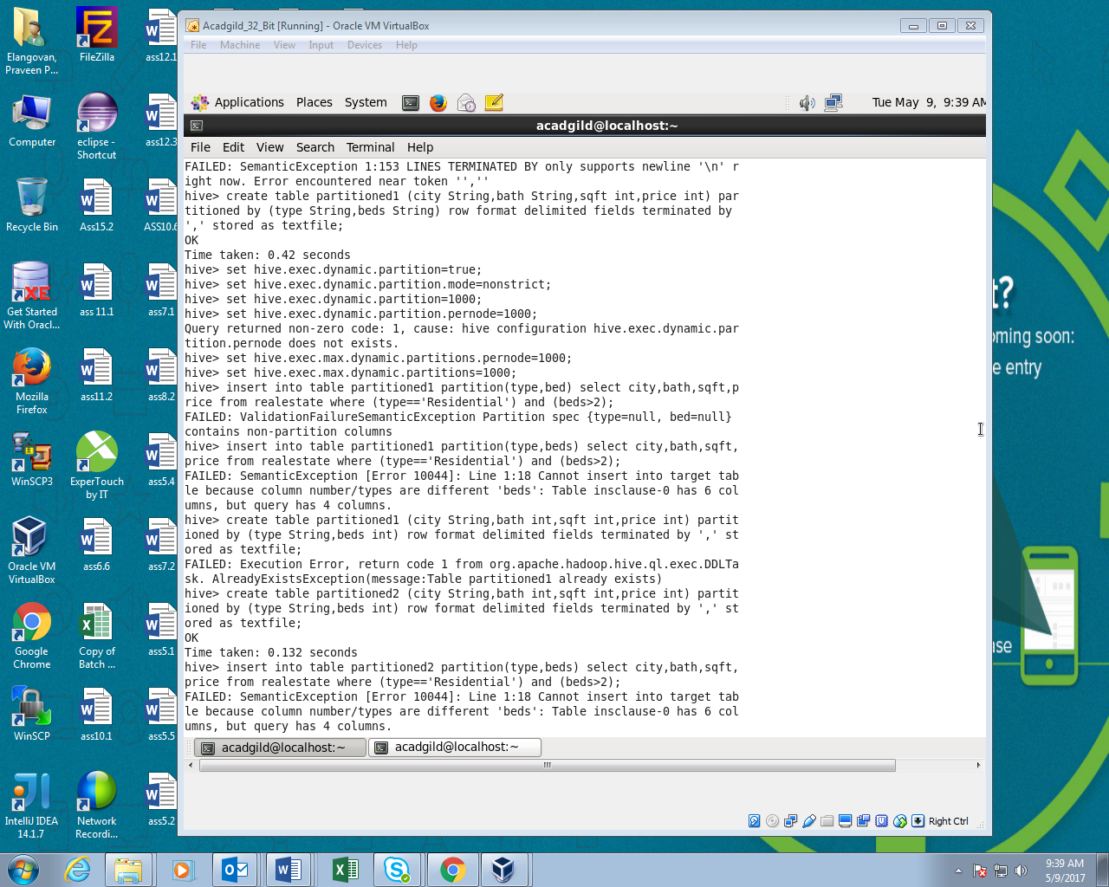

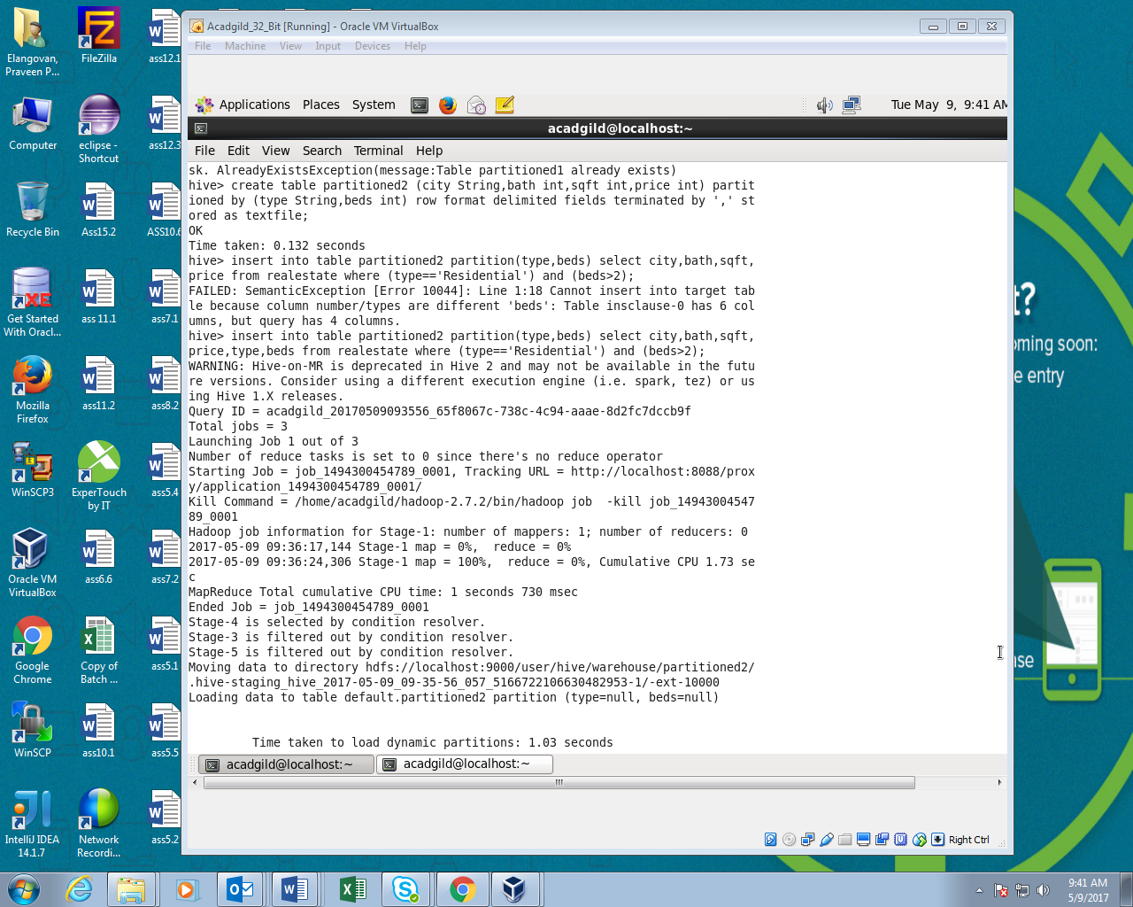

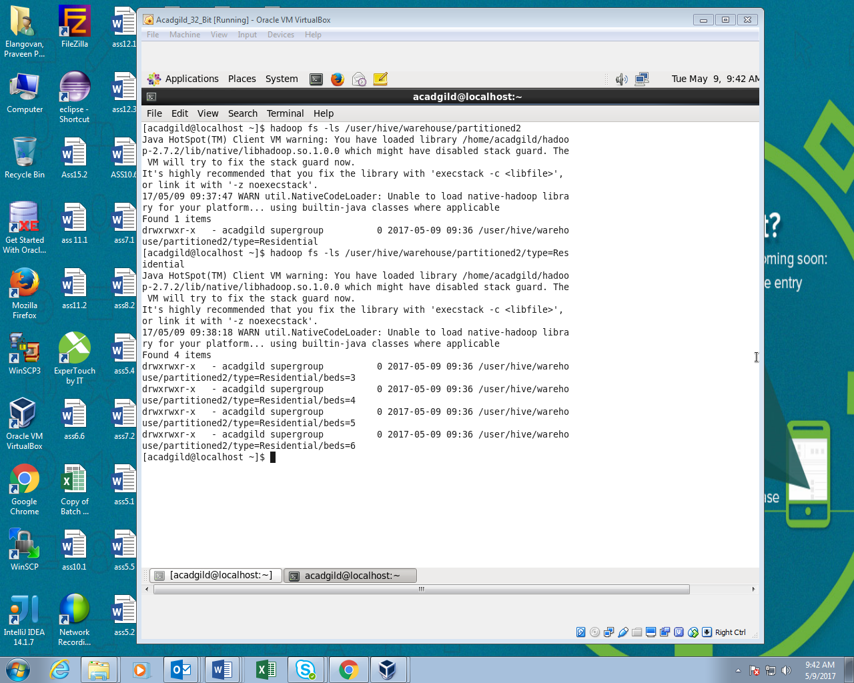

OUTPUT:

For bed=3

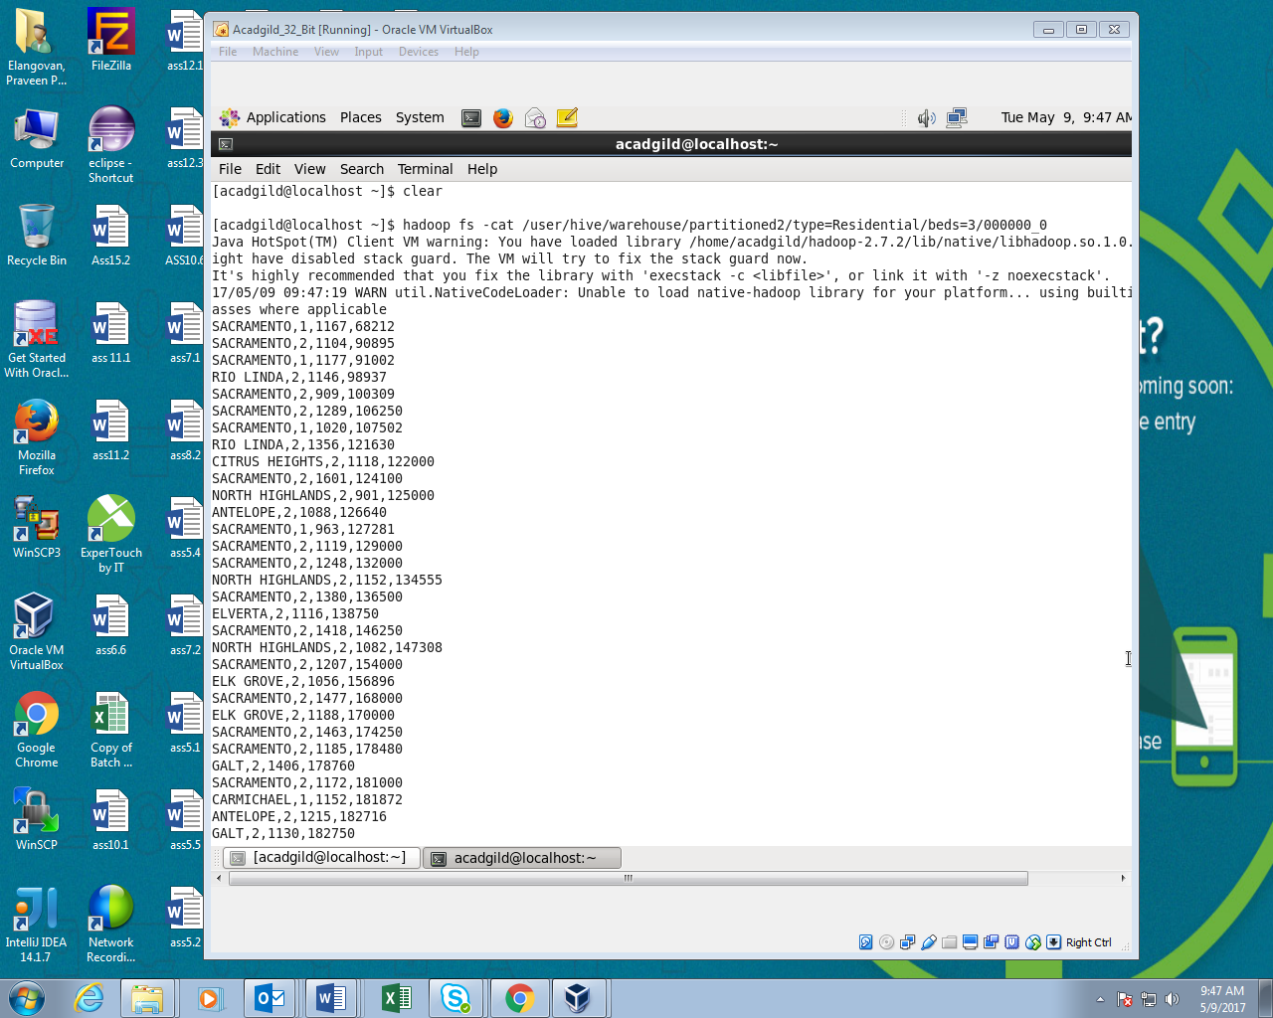

For bed=4

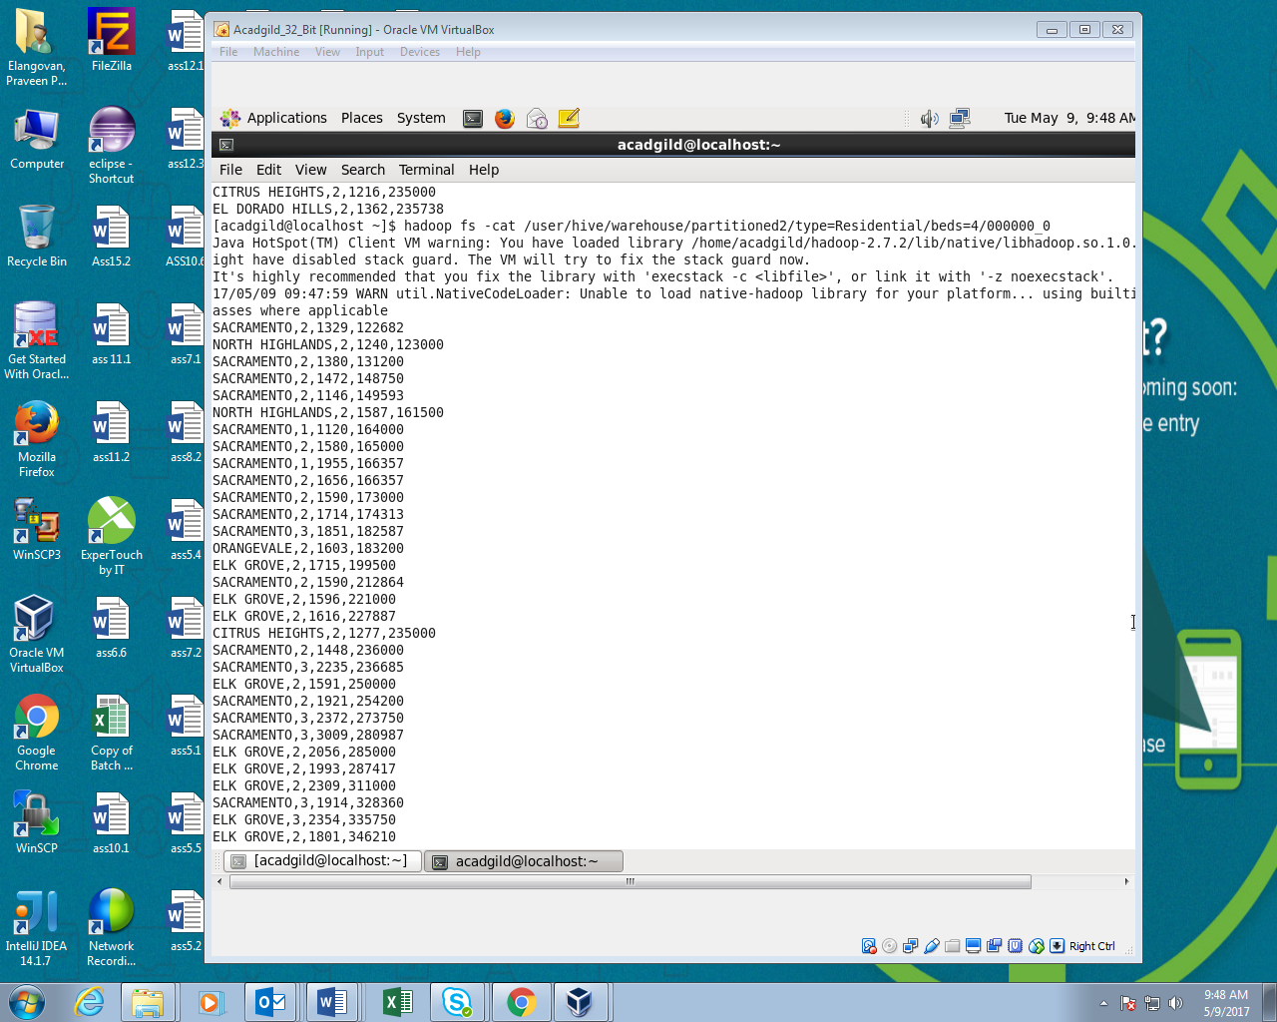

For bed=5

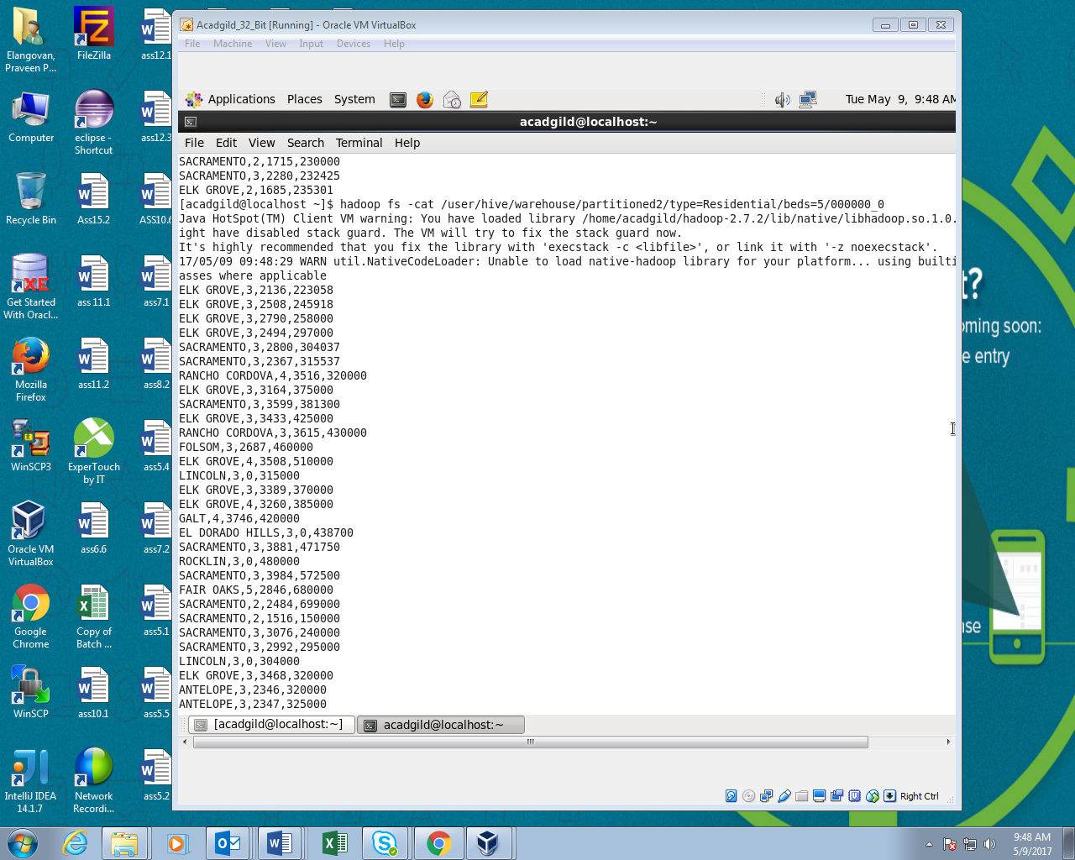

For bed=6

